Case Study 94: Disaster Relief Supply Allocation
1. Problem Statement
Compare available relief stock with area-wise requirements, prioritize urgent shortages, allocate limited supplies and calculate unmet demand.
2. Objectives
Prioritize areas by urgency.
Allocate available stock without exceeding the available quantity.
Calculate remaining unmet demand for each area.
Display stock remaining after allocation.
3. Assumptions
The example allocates one type of relief kit.
Each area has a required quantity and priority level from 1 (highest) to 3.
Areas are served in priority order; ties are resolved alphabetically.
Available stock is 100 kits.
4. Algorithm
Store area requirements and priorities.
Sort areas by priority and area name.
Set available stock.
Allocate the smaller of demand and available stock.
Reduce stock after each allocation.
Display allocated and unmet quantities.
5. Flowchart
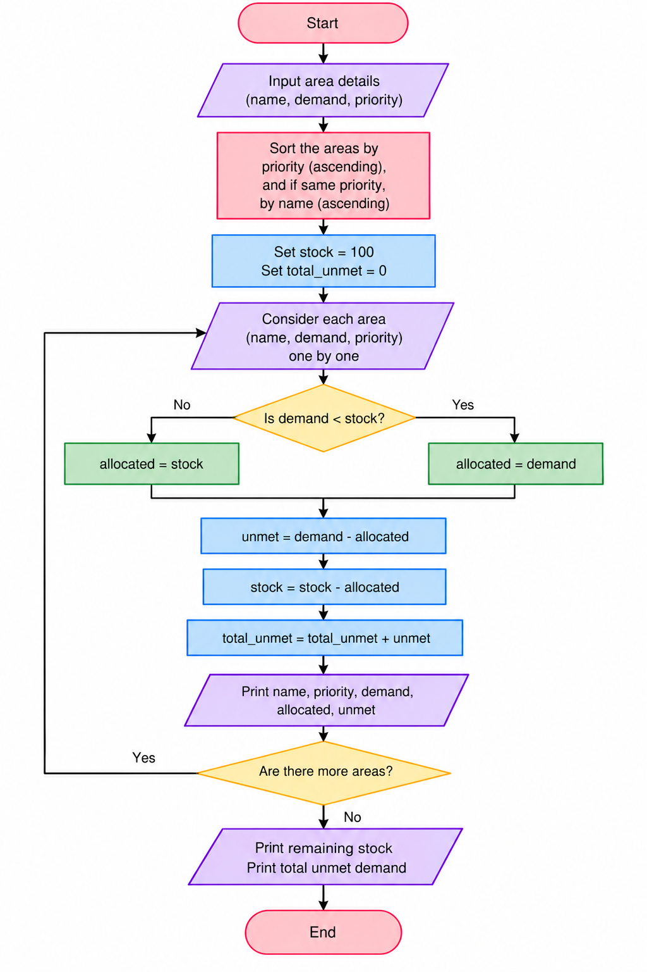
6. Pseudocode
START
Store area requirements and priorities.
Sort areas by priority and area name.
Set available stock.
Allocate the smaller of demand and available stock.
Reduce stock after each allocation.
Display allocated and unmet quantities.
Display result
STOP
7. Test Cases
Input / Record | Expected Result
East | Priority 1; allocated 35 first
South | Allocated 10; unmet 30
West | Allocated 0; unmet 20
8. Output Screenshot
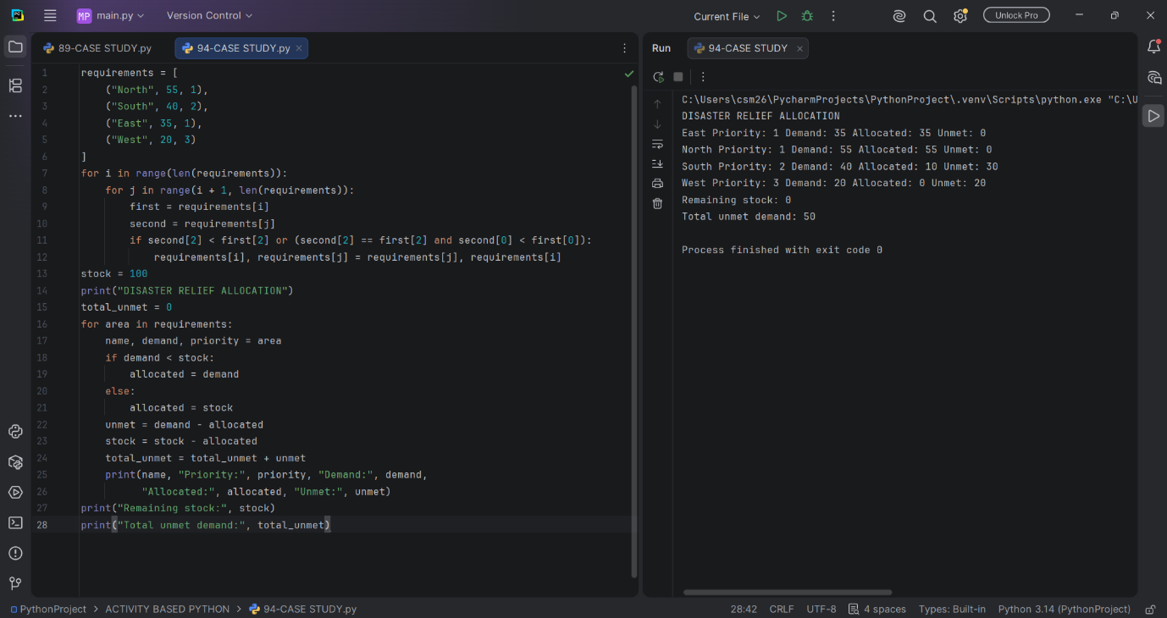
9. Conclusion
The program distributes limited relief stock according to priority and calculates unmet demand.

